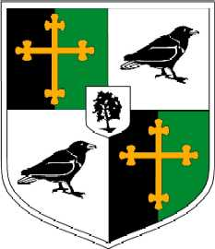
Year 12: Personalised Learning Checklist (PLC)
OCR A Level History A Unit Y223: The Cold war in Europe 1941 - 1995
Term 3
Content/Topic: | Red | Amber | Green
Key Topics
The End of the Cold War
- Economic problems in the USSR
- Social problems in the USSR
- Economic problems in Eastern Europe
- Social problems in Eastern Europe
- Gorbachev
- Glasnost Perestroika
- Perestroika
- Afghanistan
- The events of 1989 in Eastern Europe
- The 1991 coup
- Russia under Yeltsin
- The reunification of Germany
- Civil War and the break-up of Yugoslavia to 1995

