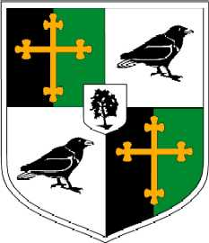
Year 12: Personalised Learning Checklist (PLC)
OCR A Level History A Unit Y113: Churchill 1930–1951 & British Period Study: Britain 1951–1997
Term 2
Content/Topic: | Red | Amber | Green
Key Topics
- Churchill and international diplomacy 1939–1951
• Churchill’s view on Britain’s world & imperial role
- relations with other wartime leaders (FDR, Stalin & de Gaulle)
• WSC’s contribution to international conferences
• His plans for post-war Europe
• WSC’s ‘Iron Curtain’ speech
• WSC’s attitude to Empire and Europe after 1945
- Conservative domination 1951–1964
- Reasons for the Conservative victory 1951
- social changes, immigration, unrest, social mobility & tensions, education, living standards, housing, prosperity & unemployment
- Conservative economic policies, Butskellism, industrial growth & stagflation
- Conservative leadership of Churchill, Eden,
- Macmillan and Home
- scandals including the Vassall affair, Philby, Argyll & Profumo
- reasons for Conservative decline
- Labour leadership, divisions & electoral failures of the Labour Party
Exam Skills
Can I compare content?
Can I compare provenance?
Can I make a judgement?

