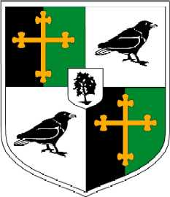
Year 12: Personalised Learning Checklist (PLC)
OCR A Level History A Unit Y223: The Cold war in Europe 1941 - 1995
Term 2
Content/Topic: | Red | Amber | Green
Key Topics
The Cold War 1956 - 1984
- Causes and events of the Hungarian Uprising 1956
- The impact of the Hungarian Uprising 1956
- The Czech Crisis 1968
- Events in Poland 1956 and 1980 - 1981
- Developments in Germany 1956 - 1984
- Rearmament of the Federal republic
- Germanys inclusion in NATO
- The Berlin Wall / causes
- The Berlin Wall events and impact
- The arms race
- The arms race and development of tensions
- The space race
- The space race and development of tensions
- Détente & SALT talks
- Ostpolitik
- The Brezhnev Doctrine
- The impact of the New Cold war (1979-85)

