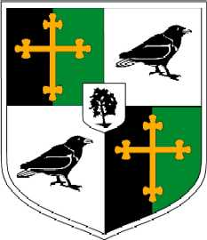
Year 12: Personalised Learning Checklist (PLC)
OCR A Level History A Unit Y223: The Cold war in Europe 1941 - 1995
Term 1
Content/Topic: | Red | Amber | Green
Key Topics
- Origins of the Cold war
- Capitalism Vs Communism / origins of conflict
- The ideological conflict
- The situation and tensions by 1941
- The Grand Alliance
- Tensions at Tehran, Yalta & Potsdam
- The liberation of Europe
- Relations ships between the leaders
- The development of the Cold war 1946 – 1955
- The Iron curtain Speech 1
- Soviet control over Eastern Europe including;
- The Baltic States, Poland, Yugoslavia
- Hungary, Czechoslovakia, Romania, Greece
- The Truman Doctrine, Marshall aid
- Cominform & Comecon
- Conflicts and Germany
- The Berlin Blockade & airlift
- Creation of East and West Germany
- NATO & the Warsaw Pact
- Atomic weapons and their impact

